Testing GUI Documentation

1. Adding items to an order

Click the button of the menu item you want to order, for example the Flying Saucer. 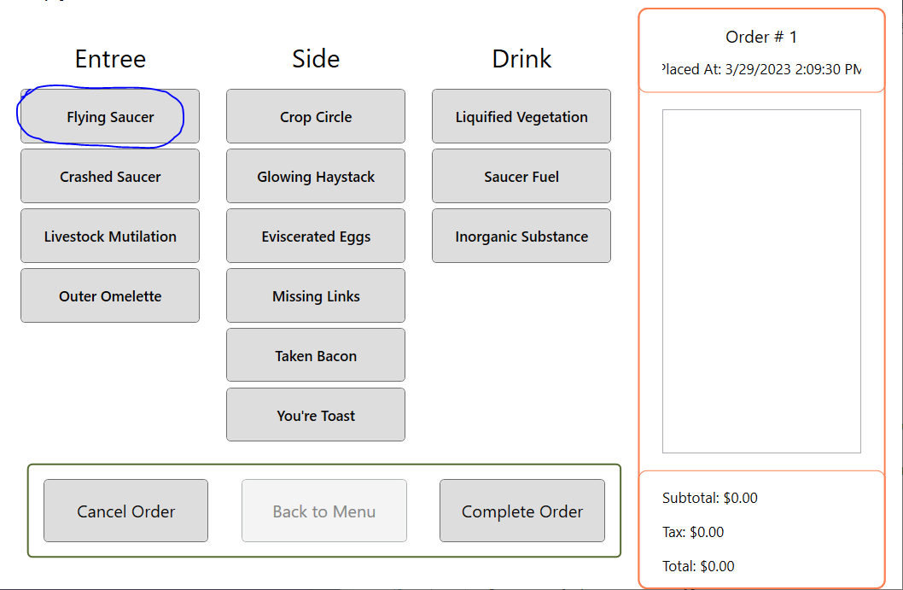

Once clicking the item to add to the order, that item should be displayed in the order. The total and tax and subtotal are updated as well. 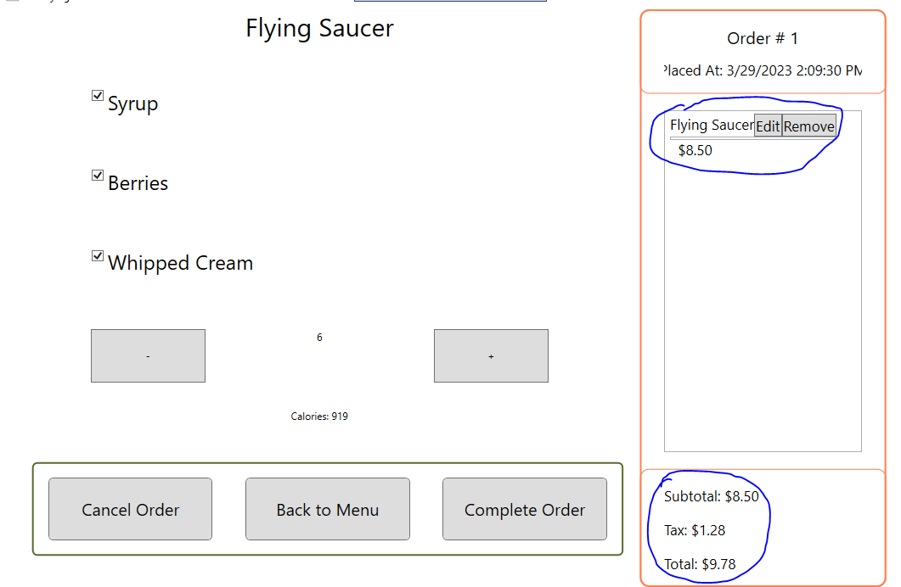

After clicking the item, you want to order, a customization screen will pop up. 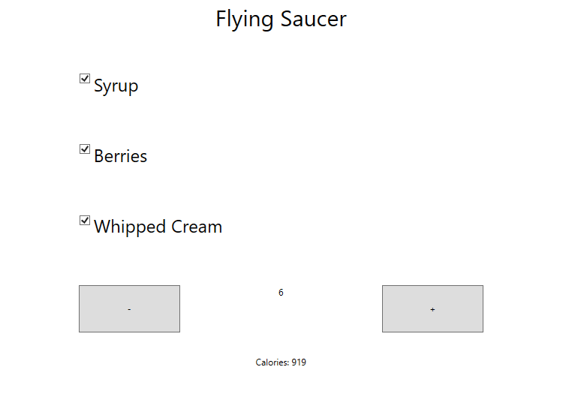

1. Customizing the items in the order as they are added

Once the customization option is displayed, you may choose if you want certain toppings, and the amount of the item you will want.

* 1. For example, the you may choose to have the Flying Saucer with syrup or without.
  2. When you make any special requests that are different that the standard way the item is made, it will display if you choose to not have syrup in the order summary
  3. Calories for the item will change
  4. Another thing that will change is potentially the price (depending on what is changed) 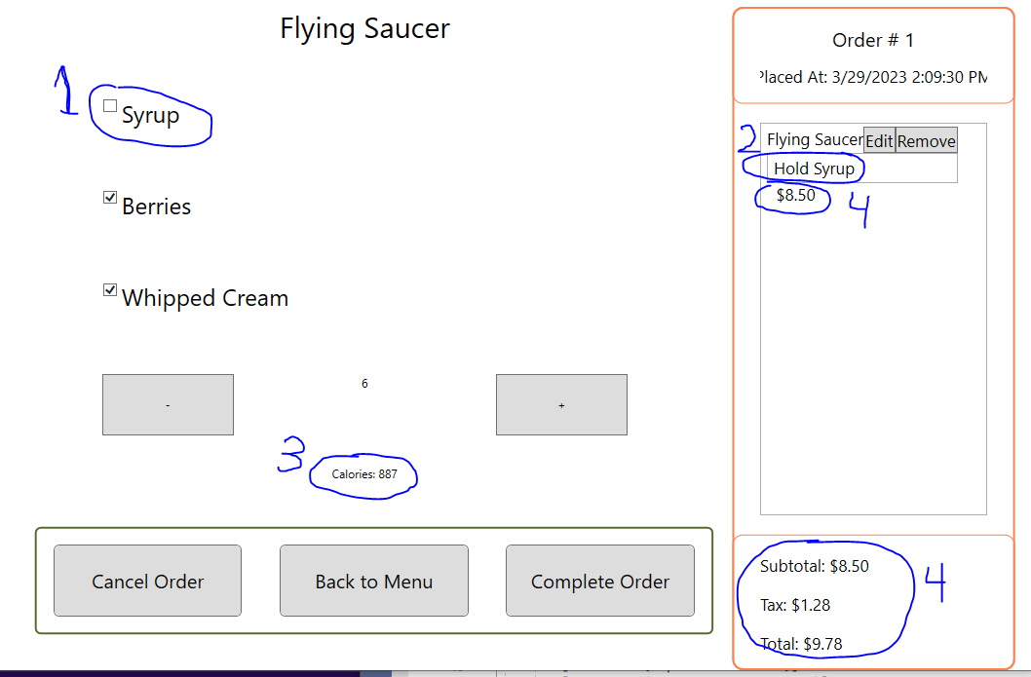

Once you have the item you would like, you may complete the order or return to the menu if you have more items you would like to buy. 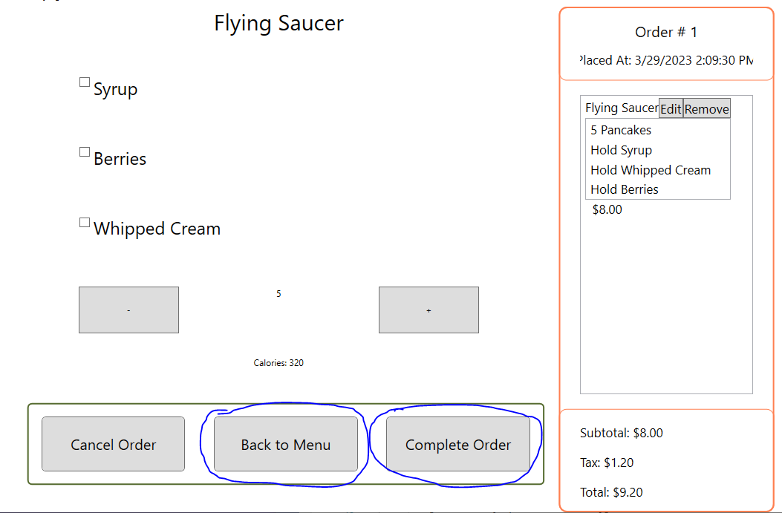

1. Customizing the items in the order if they are edited

If a mistake was made to an item added to the order, you may click edit, in the order summary next to the item you would like to edit. 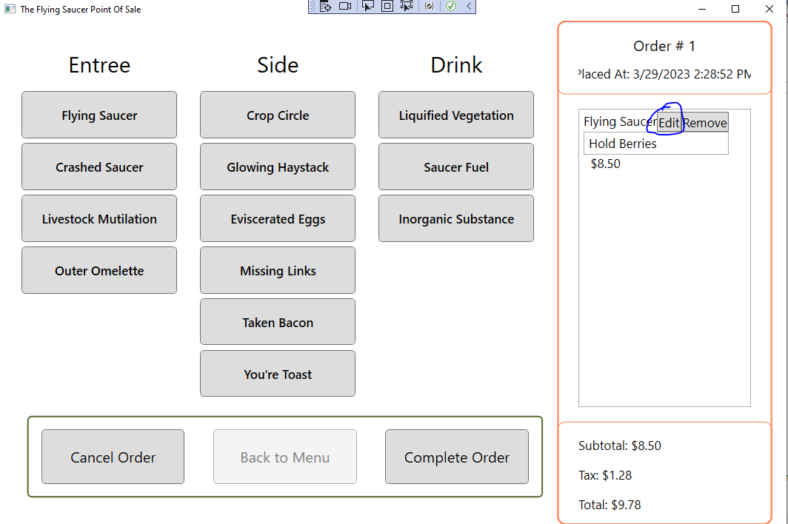

Once clicking to edit this item, the customization for that item will display and allow you to modify it again.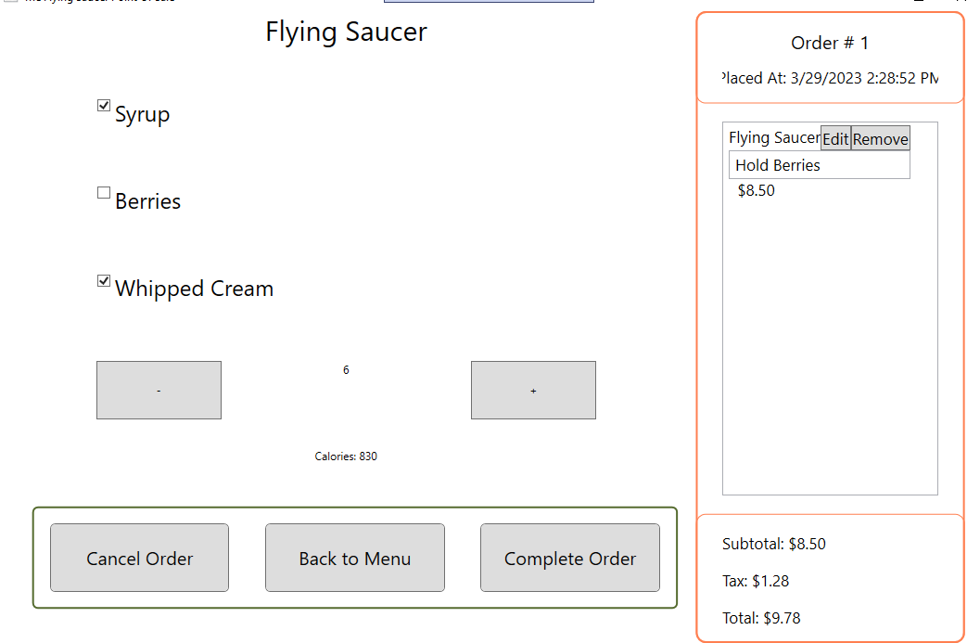

Once you are satisfied you may go back by returning to menu or hitting complete order to finish the transaction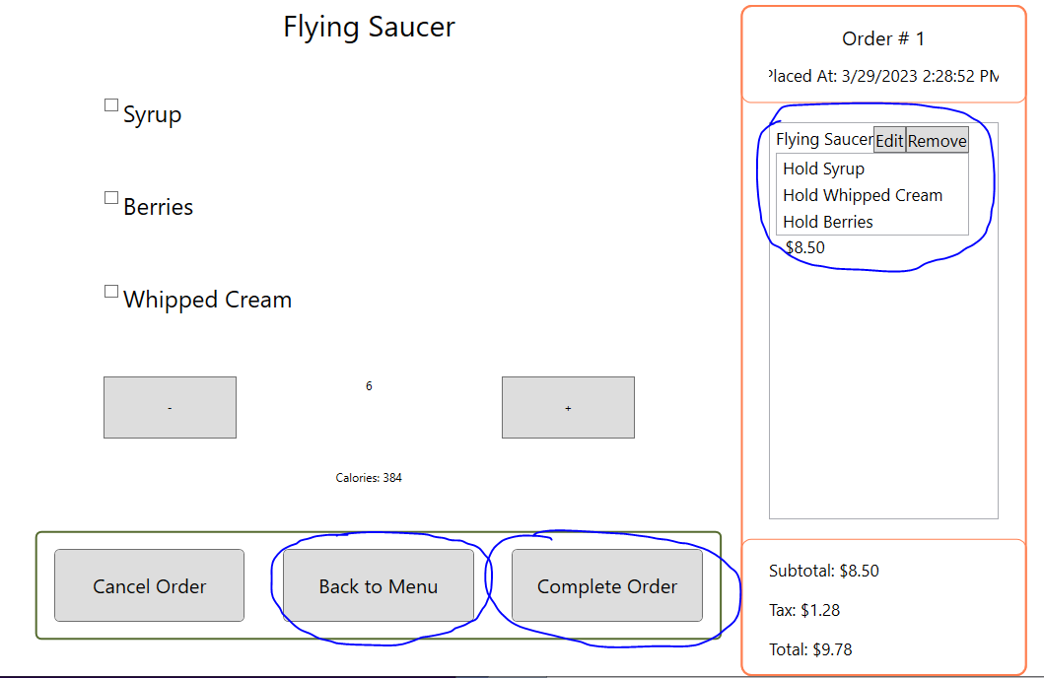

1. Removing items in the order

When wanting to remove an item from the order hit the remove button next to the item you want to remove in the order summary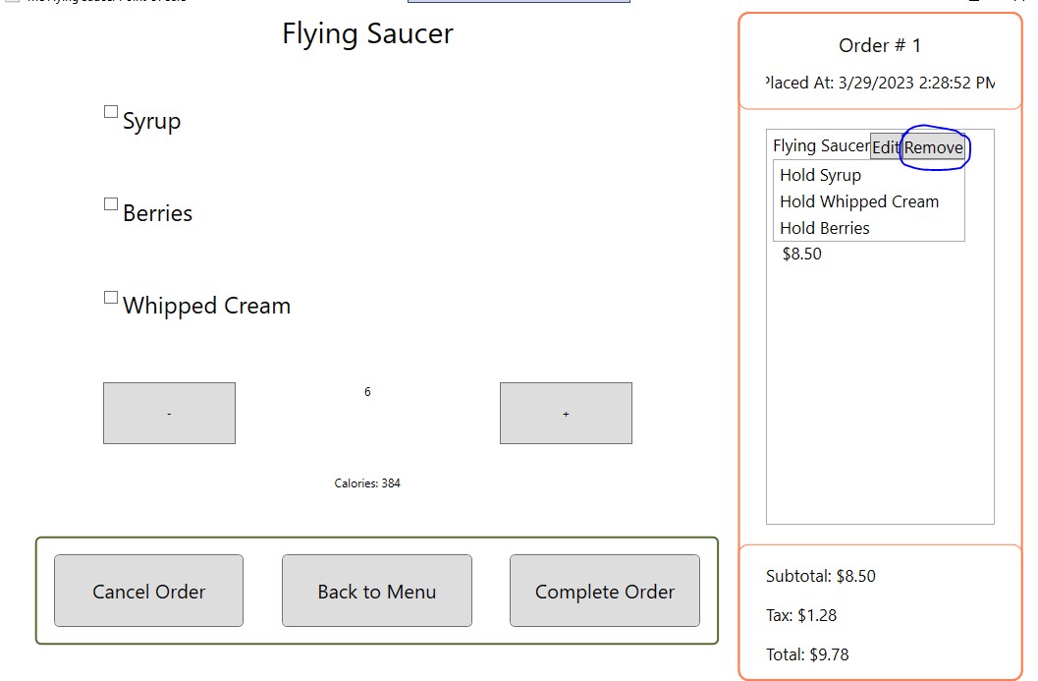

After removing the item, you will be directed back to the menu to select a new item

In the menu, the order will no longer have that item and the price will be updated. 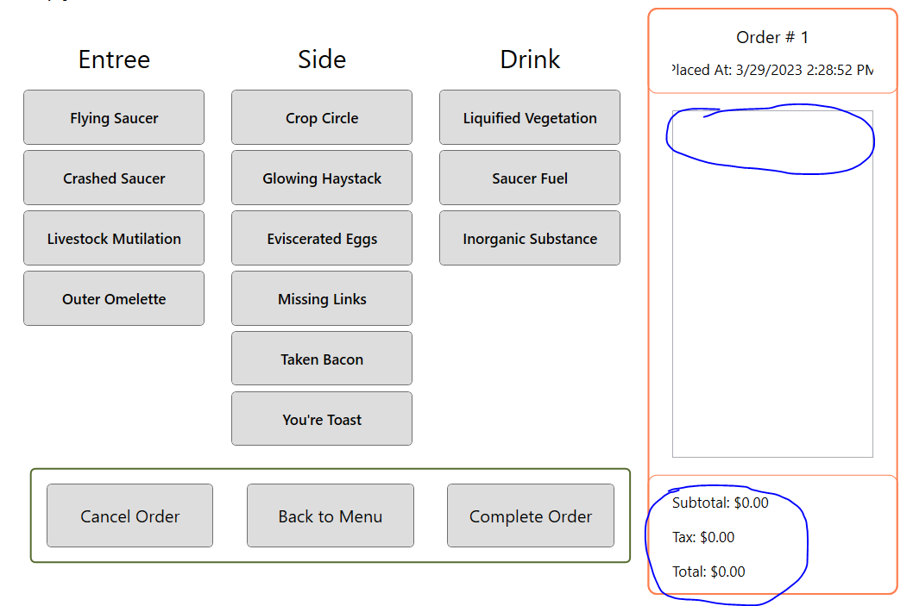

1. Taking a Credit Card Payment

When all of the items are in the order that you need, you may hit the complete order button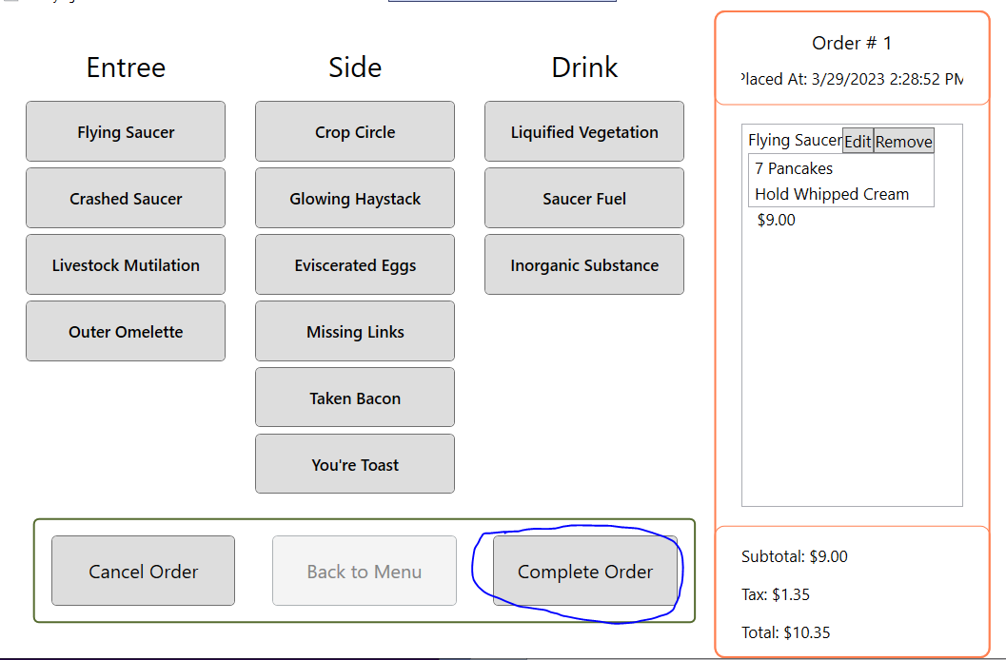

This will allow you to select either cash or credit/debit. Select Credit/debit for the card payment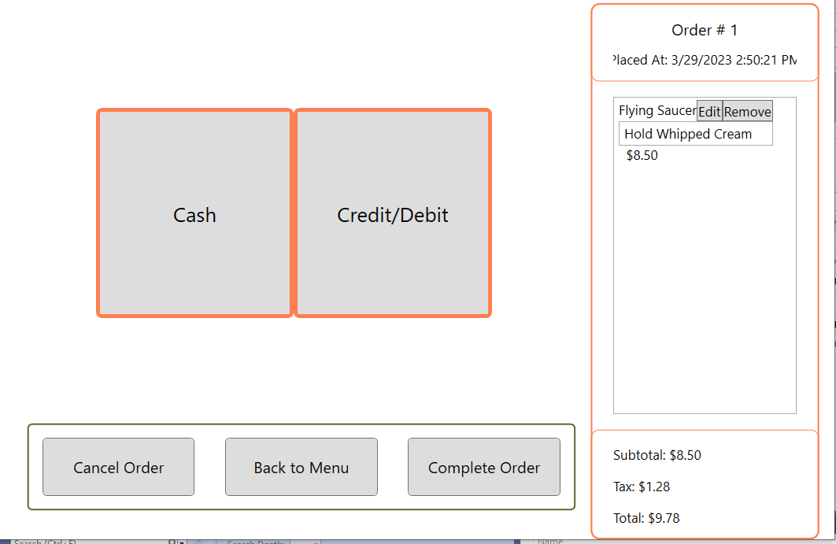

This will complete the order, unless there was an issue reading the card, and will start a new order (identified by the order number) and prompt the user back to the menu if they would like to make another order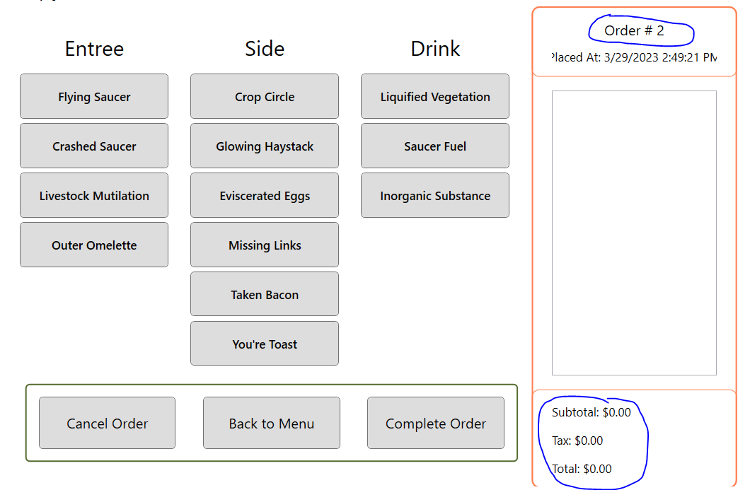

A receipt will print to summarize the transaction made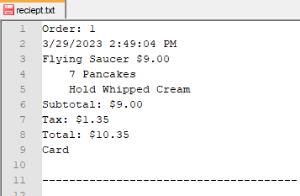

1. Taking a Cash Payment

When all of the items are in the order that you need, you may hit the complete order button.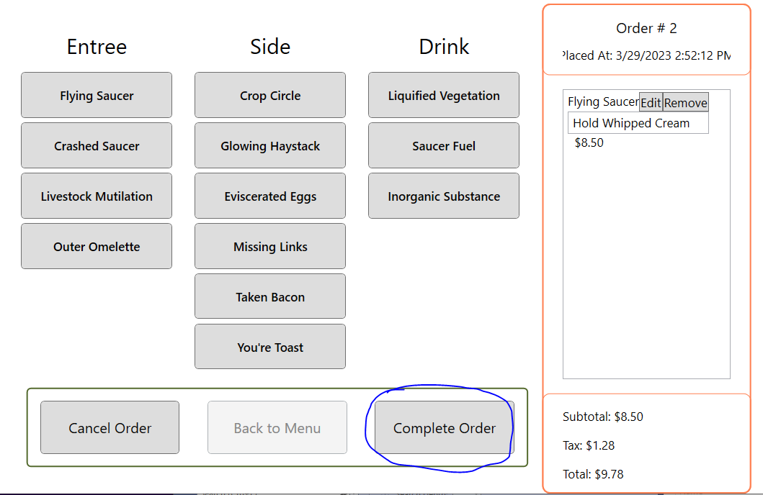

This will allow you to select either cash or credit/debit. Select cash for cash payment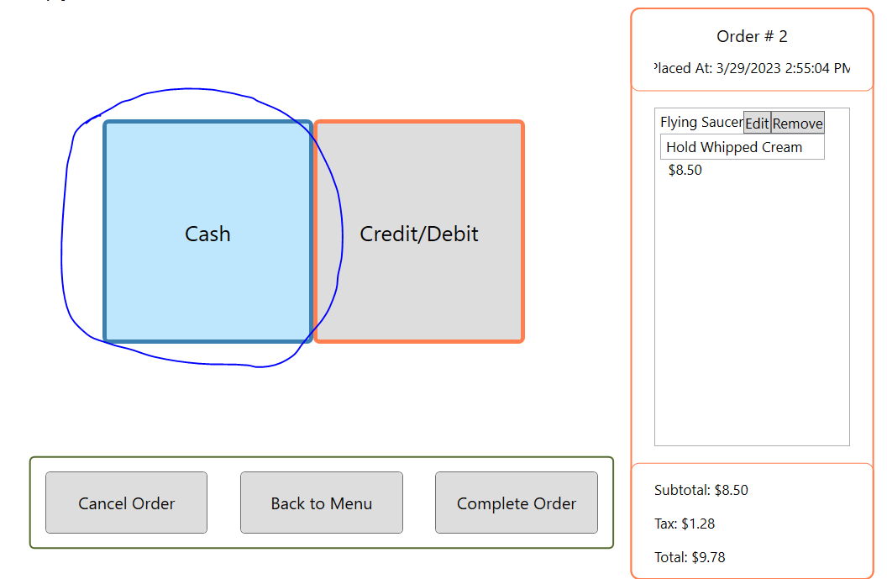

This displays the cash control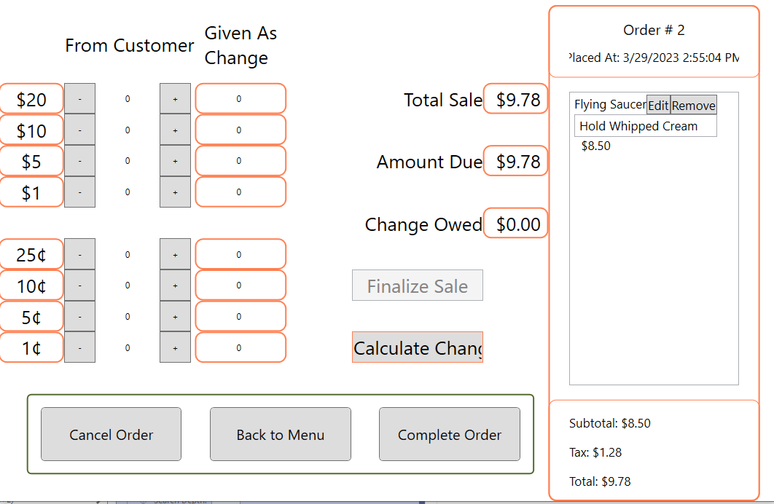

The user can update by using the +/- buttons to put in cash to pay for their item.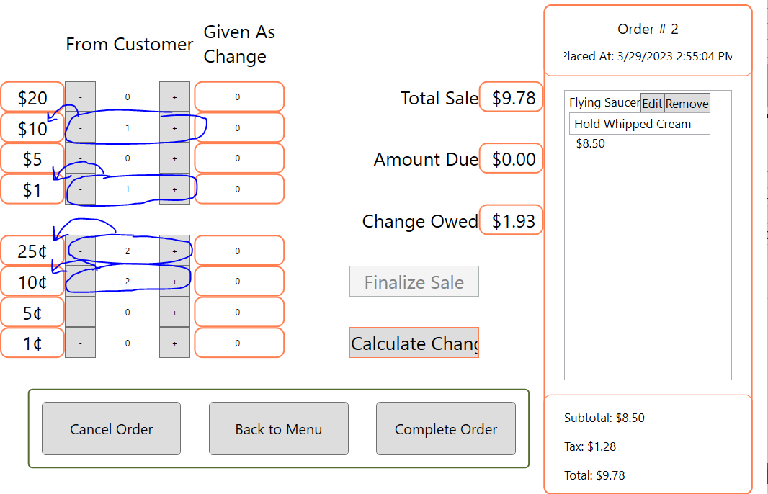

The amount due will reflect how much money the user has left to enter to pay for this order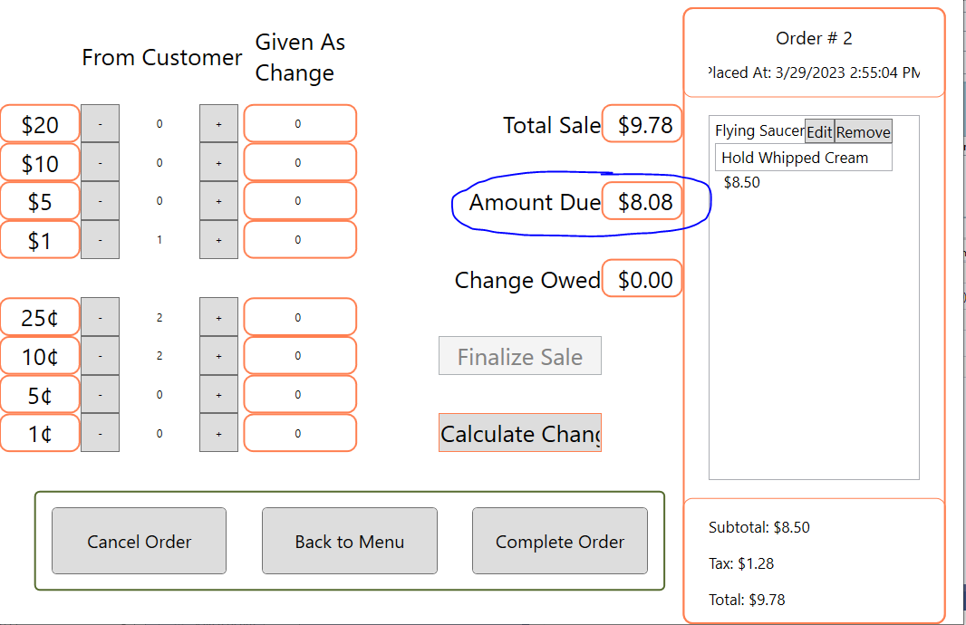

If you need change for a bill bigger than the order total, the change owed will update to reflect that amount.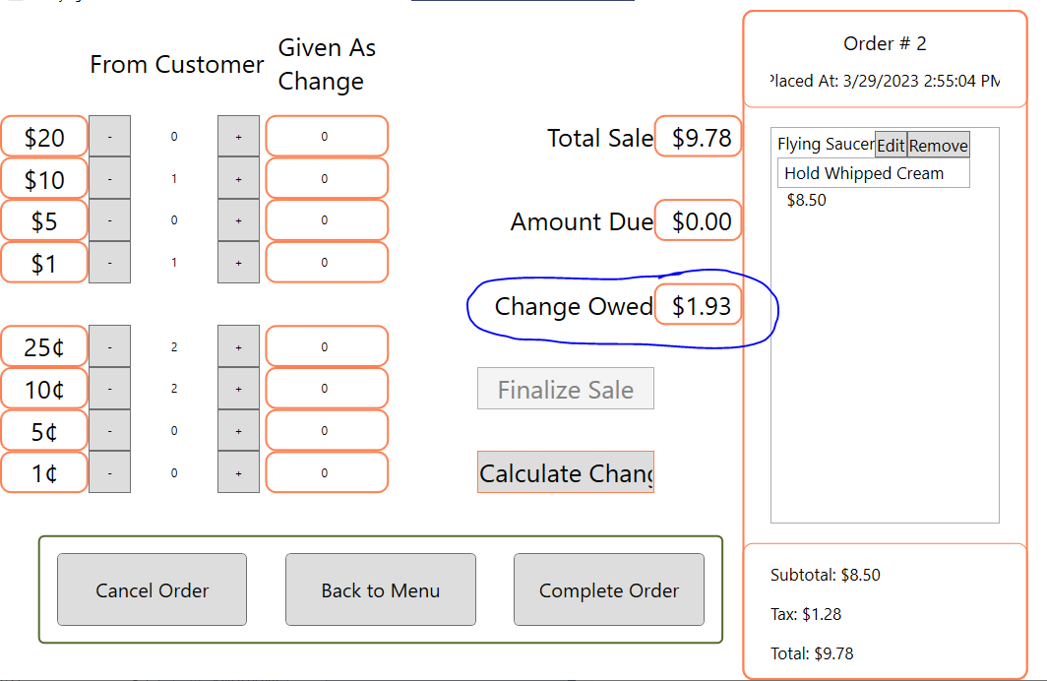

The change is also reflected next to each type of currency representing how much of that currency should be returned in change once the calculate change button has been hit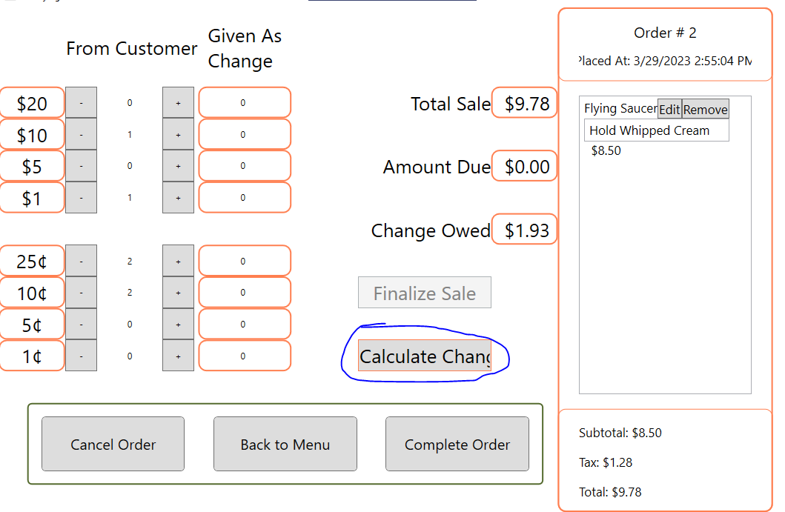

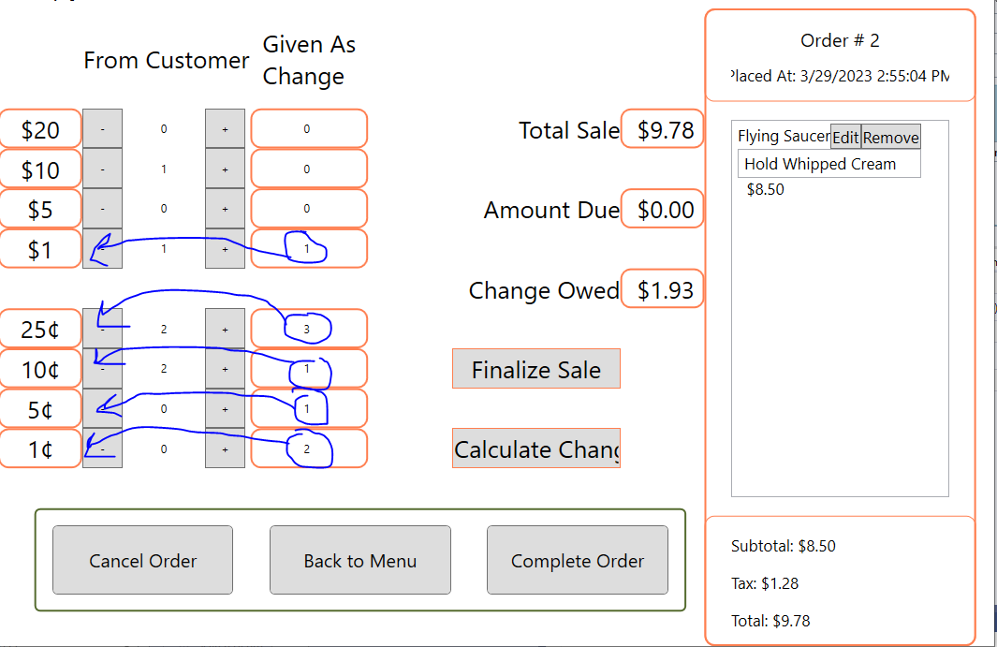

Once the user has entered enough cash to pay, and calculated the change needed, the finalize sale button will be enabled for the user to complete their order.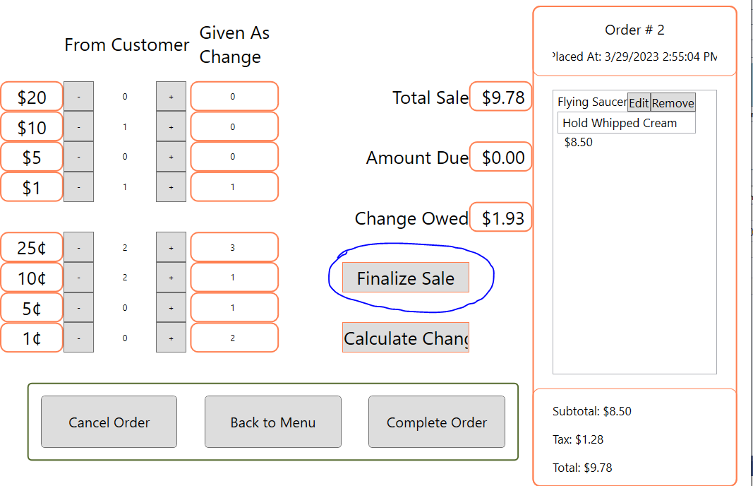

A receipt will print to summarize the transaction made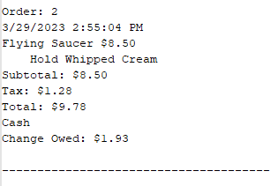

The display will start a new order (identified by the order number) and prompt the user back to the menu if they would like to make another order.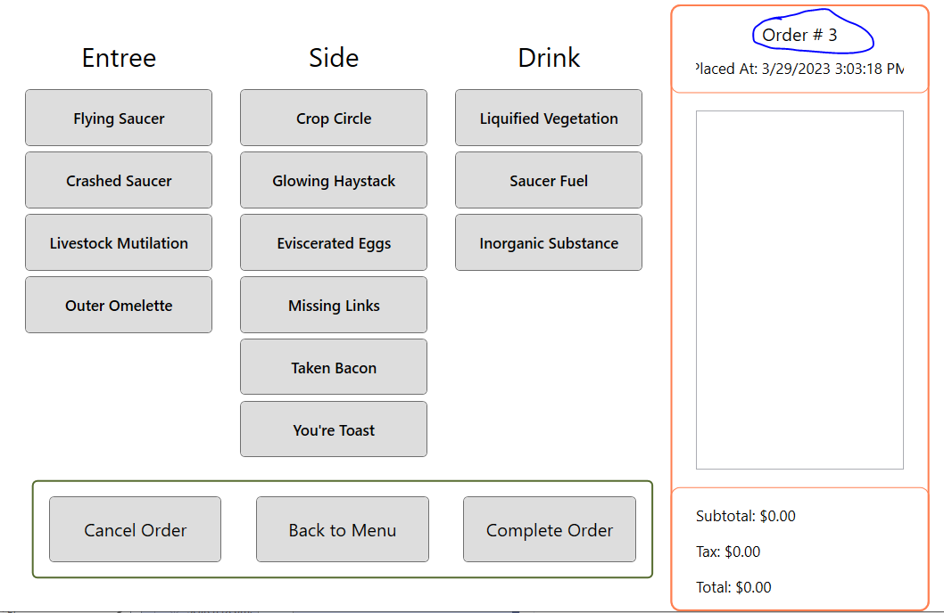

1. Stopping taking a payment early to return to the order and adding additional items

When taking a payment, at any point you may hit the back to menu button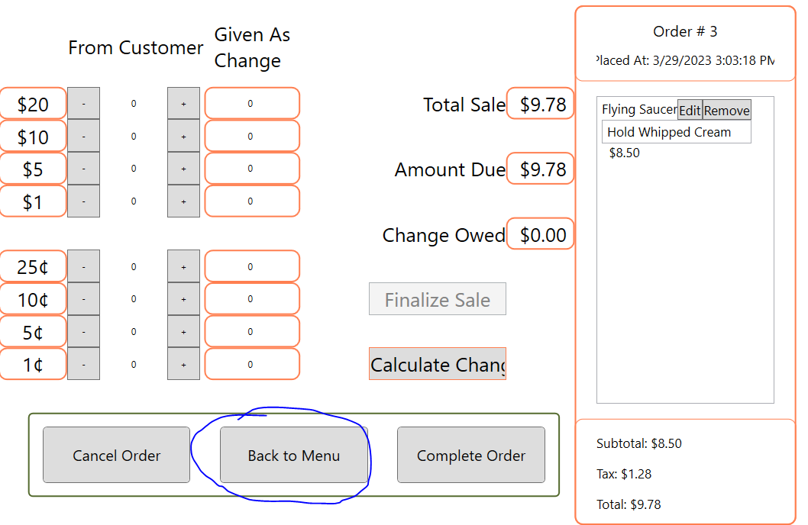

Once hitting back to menu, it will return to the menu allowing you to add more items before you pay for the order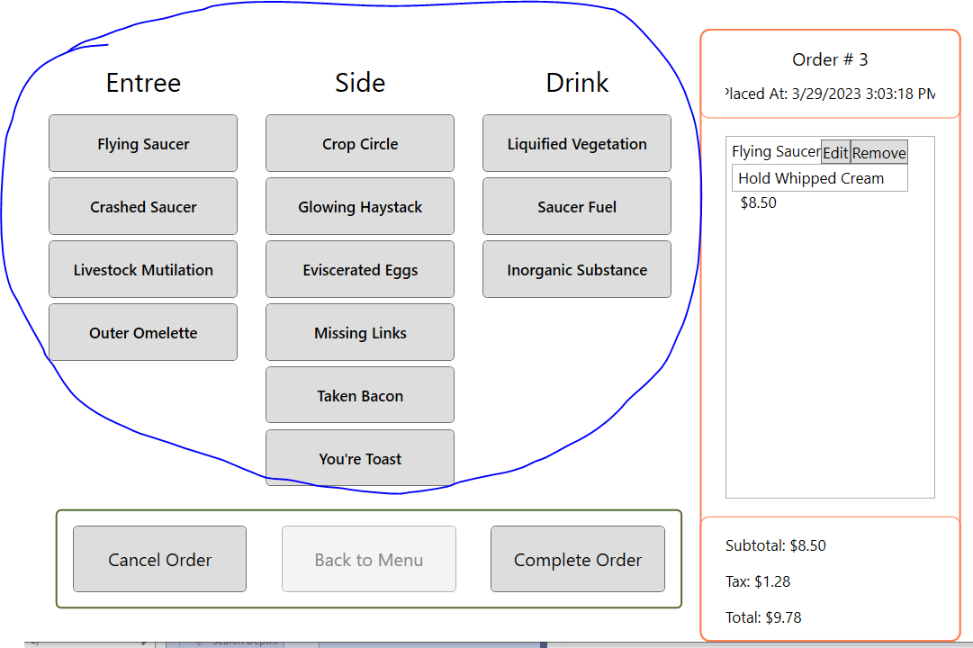

1. Canceling the order and starting a new one

At any point throughout the order, you may hit cancel order 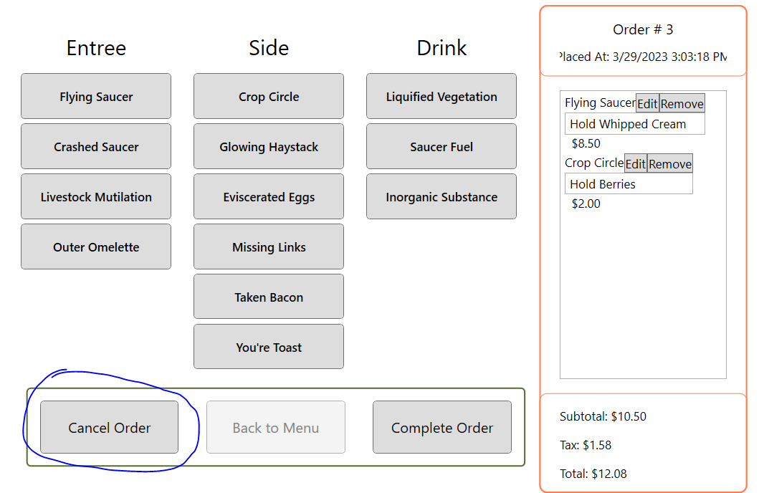

This will delete your entire order and create a new one (indicated by the order number)

Once hitting cancel order will have returned you back to the menu to select items for your new order